ESP 4 Cheque Register to Suppliers and Final Merging
Legend Bold primary key
Italic foreign key
BoldItalic primary/foreign key
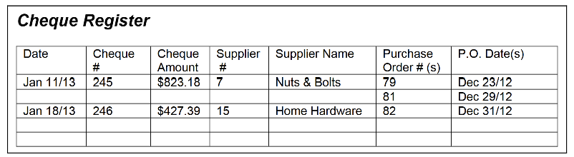
0NF
Cheque(ChequeNumber, ChequeDate, ChequeAmount, SupplierNumber, SupplierName,
(PurchaseOrderNumber, PurchaseOrderDate))
1NF
Cheque (ChequeNumber, ChequeDate, ChequeAmount, SupplierNumber, SupplierName)
NOTE: the PurchaseOrderNumber is also unique
The narrative stated that the entire PO is paid at one time
Quesiton? Do we really need a compound pkey in this situation?
Possibilities: We still need the ChequeNumber to link to the Cheque table
Can the ChequeNumber then just be a foreign key in the new table?
Is a PO paid over multiple cheques? NO
Here we can consider making the ChequeNumber just a foreign key
Within the new table
PurchaseOrder (ChequeNumber , PurchaseOrderNumber, PurchaseOrderDate)
2NF
Cheque (ChequeNumber, ChequeDate, ChequeAmount, SupplierNumber, SupplierName)
PurchaseOrder (ChequeNumber , PurchaseOrderNumber, PurchaseOrderDate)
3NF
Cheque (ChequeNumber, ChequeDate, ChequeAmount, SupplierNumber)
PurchaseOrder (ChequeNumber , PurchaseOrderNumber, PurchaseOrderDate)
Supplier (SupplierNumber, SupplierName)

Merging

Item ( ItemNumber, Description, CurrentSalePrice, InStockQuantity, ReOrderLevel)
PurchaseOrderItem (PurchaseOrderNumber, ItemNumber, SupplierItemNumber, PurchaseQuantity, PurchaseCost, PurchaseOrderAmount)
PurchaseOrder (PurchaseOrderNumber, SupplierNumber, PurchaseOrderDate, Subtotal, GST, Total, ChequeNumber)
Supplier (SupplierNumber, SupplierName, Address, City, Province, PostalCode, SupplierPhone)
SupplierCatalog (SupplierItemNumber, SupplierDescription)*
Customer (CustomerNumber, FirstName, LastName, Address, City, Province, PostalCode, HomePhone)
Order (OrderNumber, CustomerNumber, OrderDate, Subtotal, GST, Total, BalanceOwning)
OrderItems (OrderNumber, ItemNumber, Quantity, OrderPrice, Amount)
PaymentLog (PaymentLogID, OrderNumber, CustomerNumber)
PaymentLogDetail (PaymentLogID , PaymentNumber, PaymentDate, PaymentAmount, PaymentTypeID, DepositBatchNumber)
PaymentType (PaymentTypeID, PaymentTypeDescription)
Cheque (ChequeNumber, ChequeDate, ChequeAmount, SupplierNumber)

